[Project Name]
[Document Title]
  - Prepared for [Client Name]
[Month, Year]
[Document Number]
Project Number [XXXX]


Contents
Document Control
Revision | Issue Reason | Date | Prepared | Reviewed | Approved
A |  | [XX/XX/XXXX] | [Author Name] | [Reviewer Name] | [Approver Name]
A person using Agilitus Pty Ltd documents or data accepts the risks of:
a) using the documents or data in electronic form without requesting and checking them for accuracy against the original hard copy version; and
b) using the documents or data for any purpose not agreed to in writing by Agilitus.

1. Introduction 2
1.1 Calculation Objective (Scope) 2
1.2 Assumptions 2
1.3 Exclusions 2
1.4 Design Criteria 2
1.5 Design Standards, Client Specification and Codes 2
1.6 Other Reference Documents 3
1.7 Methodology and Structural Load Path 3
1.8 File Location and Software Use 3
1.9 Other 4
2. Drawing List 5
3. Loading and Load Combinations 6
3.1 Load Case 1 – Self Weight G(SW) 6
3.2 Load Case 2 – Structural Dead Load G(Sdl) 6
3.3 Load Case 3 – Mechanical Dead Load G(Mech) Error! Bookmark not defined.
3.4 Load Case 11 – Floor Live Load Q(L) Error! Bookmark not defined.
4. Modelling, Member Capacities and Serviceability 7
5. Connections 8
6. Foundation Design 9

Appendices
10
Appendix A - Design Sketches 11
Appendix B - Calculation Check 12

Right click and choose Update Field to update the table of contents. Main table of contents and appendix table of contents need to be updated separately.

Introduction

Calculation Objective (Scope)
Outline the scope this calculation covers as per the example below.
This calculation covers the design of the structural steel and foundation for the building.
The structural steel consists of three individual sub-structures isolated to control vibrations. These buildings are all braced framed systems and columns are considered pinned base.
Foundations are either combined or individual spread reinforced concrete footings.
In addition to the main structural framing, this calculation verifies the structural adequacy of:
- Footings including holding down bolts,
- Mechanical frames and equipment plinths,
- Associated chute-work and chute supports.

Assumptions
List any relevant assumptions such as mechanical settlement criteria, density of backfill on retaining walls. Assumptions should be minimised and always support by approval from project. Where appropriate, assumptions should be recorded in the project risk register.

Exclusions
Outline the exclusions this calculation does not cover as per example below.
This calculation excludes the following:
- Design of the process / mechanical function for items where structural design has been completed, e.g., chutes and hoppers. Refer to mechanical engineer documentation for details,
- Structural design of vendor supplied equipment including XRT machine and screens.

Design Criteria
Unless specifically noted, this calculations in accordance with the requirements of Client design criteria xxxx and associated documents list in this criteria document.

This calculation has been completed in accordance with project procedures xxxx. The Basis of Design for this calculation is described in xxxx with mechanical load data in accordance with the Process Design Criteria xxxx. (Include any variations to design criteria including materials and these are to be approved by the Technical Director prior to undertaking calculations).

Design Standards, Client Specification and Codes
Unless specifically noted, the design complies with Australian Standards and selected international standards as listed in the Design Criteria. The following summarises the key standards used in producing this calculation: (Limit to main standards not exhaustive list – this can be done in the design criteria).
- AS 1170.0 – 2002 Structural design actions – Part 0: General principles,
- AS 1170.1 – 2002 Structural design actions – Part 1: Permanent, imposed and other actions,
- AS 1170.2 – 2011 Structural design actions – Part 2: Wind actions,
- AS 1170.4 – 2007 Structural design actions – Part 4: Earthquake actions in Australia,
- AS 1418.1 – 2002 Cranes, hoists and winches – Part 1: General requirements,
- AS 3600 – 2018 Concrete structures,
- AS 4100 – 1998 Steel structures.

Other Reference Documents
List other relevant documents – their number and their revision where necessary as per example below:
Other reference documents used in this design include:
- Geotechnical Interpretive Report,
- Certified Vendor Drawings,
- Mechanical Drawings.

Methodology and Structural Load Path
Outline briefly the structural form being used, a summary of load types, load combinations and what their basis is. Include a brief description of key load paths as per the example below.
This section should be no more than half a page.
The structural system consists of steel braced frames. All floors and columns grids are braced to control vibration.
Structural linear analysis was performed on the structural models in Space Gass to confirm member capacities and connection loads.
Load combinations for both strength and serviceability requirements were based on the worst combinations of dead, live, equipment, wind loads, and earthquake. (As applicable)
The connection checks were completed using Idea Statica.
The dynamic analysis of the secondary screen support under the XRT building and the primary screening building were done using Strand7 program complying with the basis of design.
The main loads this structure carries are as follows:
- Gravity loads from XRT machine and screens,
- Platform live loads,
- Gravity and vibration load from screen feeders and crushers,
- Conveyor loads including belt tensions,
- Horizontal wind loads,
- Earthquake loads.
In terms of horizontal loads, the wind loads control the design of the structure.

File Location and Software Use
List file path for final version of electronic files and list software utilised.

File Location

Software utilised
- Space Gass V xxxx
- RAMConnect V xxxx
- Idea Statica V xxxx

Other
Include any other relevant considerations that have formed part of the design and documentation process.

Drawing List

This calculation covers the structural components for the drawings listed in Table 2.1.
Drawing Number | Title | Revision No.

Note – Revision quoted is current at time of completion of calculation. This calculation does not cover structural adequacy subsequent revisions.

Loading and Load Combinations
Load cases and load case templates should match Agilitus’ standard loading templates.
- Include design loads spreadsheets,
- Include copy of reference vendor drawings,
- Include copy of reference drawings of other disciplines,
- Include screen shots for analysis model demonstrating loads have been included correctly,
- Include list of load cases and combinations used in analysis software. Clearly identifying which are for serviceability and ultimate. Matrix format preferred.
Organise loads by load case with each load case having it separate heading.

Normally this section will be PDF insert of “AGIL-ST-CAL-0001_0 - Loading Calc Template Process Structure.xls”

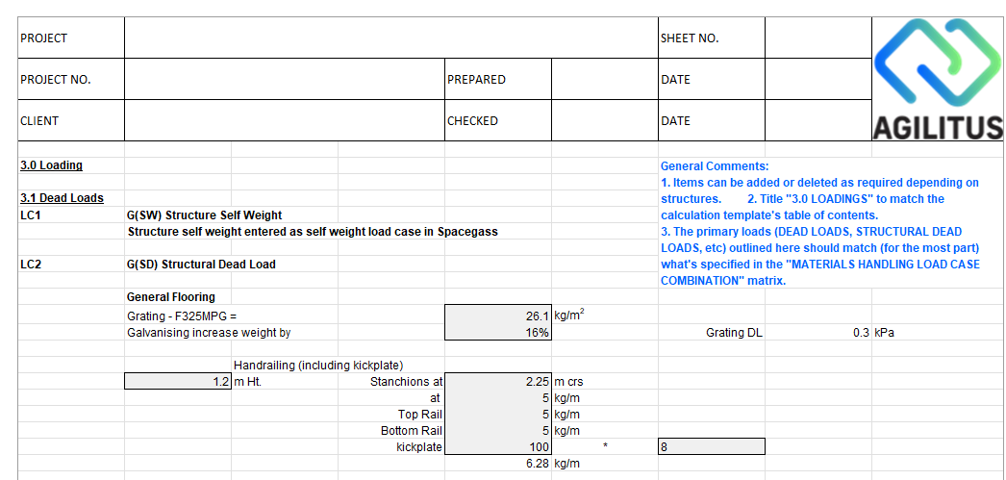

Where the loading template is note used please follow the same section headings as the template.

Load Case 1 –G(SW) Structure Self Weight
Self-weight has been entered using gravity function with-in analysis software.

Load Case 2 – G(SD) Structural Dead Load
Provide calculation.

And so on …

Modelling, Member Capacities and Serviceability

- Include screen shots that show member sizes,
- Provide statement describing how member restraints have been developed, e.g., lateral restraints applied at incoming at incoming beams that are part of a brace system,
- Include a list of member capacity ratios demonstration adequacy,
- Provide deflection outputs that demonstrate compliance with serviceability requirements,
- Include hand calculations as required,
- Include separate section for crane beams and monorails that allows easy identification of these elements including clear demonstration of compliance to AS 1418 deflection requirements.

Connections
- Include design loads from analysis software,
- Include Idea STATICA outputs,
- Include hand sketches.
- Include hand calculations,
- Ensure each connection is clearly identified.

Foundation Design
- Include design loads from analysis software,
- Include corporate standard spreadsheet outputs,
- Include holding down bolt and pedestal checks,
- Include hand sketches,
- Include hand calculations,
- Ensure each footing and pedestal is clearly identified.

Appendices


- -
Design Sketches

Include a copy of sketches and mark-ups providing to drafting.

- -
Calculation Check

Include a copy of Check Calculations.

